KUIC Allied Health Professions Interview Guide

- Personal Statement
The scoring system used in Physiotherapy and radiography looks for the personal statement and academic references to include the following:
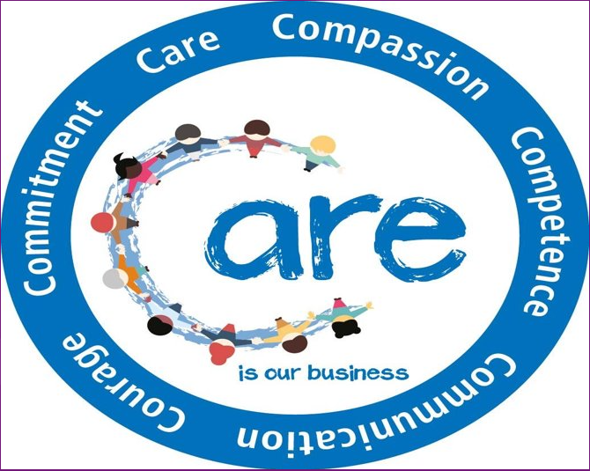
- Reference highlights suitability for profession
- Coherent personal statement
- Health related work experience
- Interest (extra-curricular activities)
- Leadership
- Teamwork
- Understanding of the profession
- Evidence of the 6C’s

NHS England 2016
A1. Work Experience
- Not all students get work experience within the field they wish to study.
- Many hospitals and clinics now have much stricter privacy and confidentiality agreements in place that prevent students observing
- Ideally observing a clinician is the ‘gold’ standard
- Experience should link to the 6C’s so any caring roles or volunteer work with individuals with disabilities can count.
Examples of Adequate Work Experience
- Caring for a sibling or family member with a disability.
- Volunteer experience with a charity that works with the vulnerable (Adults or Children)
- Employment experience of supporting individuals with specialist needs.
A2. Supplementary Knowledge
- Charted Society of Physiotherapy
www.csp.org.uk

- Society of Radiographers
www.sor.org

- Alumni and current students

- Interview Process
Interview offered on basis of grades and scoring (Veracity of personal experience, understanding of profession, situational judgement)
Multiple Mini Interviews
MMI follows a Values Based Recruitment model across a number of testing stations testing each of the required needed of a health professional
There can be a number of different stations, included ranging from up to 4 in physiotherapy to up to 12 in medicine.
Stations for physiotherapy may include (model also used in radiography):
- Understanding the profession
- Motivation for being a physiotherapist
- Scenario - challenging situations
- Scenario – challenges of student life
- Understanding personal attributes of a physiotherapist
- Understanding professionalism

Useful tips
Research the course
Programme website
https://www.keele.ac.uk/study/undergraduate/undergraduatecourses/physiotherapy/
https://www.keele.ac.uk/study/undergraduate/undergraduatecourses/radiographydiagnosticimaging/

Interview Guidance
https://www.keele.ac.uk/interview-guidance/
Research the profession

- Explore the speciality area and job roles/opportunities
- Explore professional body requirements
- Consider ethics

KUIC Allied Health Professions Personal Statement Template

Name | Student ID | Degree Course (Please Delete)
 |  | Physiotherapy / Radiography (Diagnostic Imaging)

Your personal statement must be submitted via Studylink no later than 48 hours prior to your admissions interview and will form part of the discussion within the interview.

Failure to submit the personal statement by the required deadline will automatically cancel the interview.

Due to the highly competitive nature of the course, the college and Keele University may not be able to reschedule the interview.

Please answer the below questions fully.

- Why do you want to study your chosen healthcare profession?
(Please specify the course you wish to study at the top of the form).

- Specifically, why do you want a career in your chosen healthcare profession?
(Please specify the course you wish to study at the top of the form).

- What healthcare related academic, volunteering and / or work experience (internship or shadowing) do you have already and how will that help you in your field of choice? (Please provide details and relate to your chosen healthcare programme).

- What skills, attitudes, values, and character traits do you possess to make you a suitable candidate for your chosen healthcare profession?
(Please note that transferrable skills can also be considered).

- Why do you want to study your chosen programme at KUIC and Keele University?
Reminder: Submit the statement via Studylink.

